Table of Contents
A1: Analyzing the Problem………………………………………………………………………………………………………………………1
Interview with Mark Harris………………………………………………………………………………………………………………………3
Interview with Don from Sporthaus…………………………………………………………………………………………………………5
A2: Criteria for Success…………………………………………………………………………………………………………………………….6
Hierarchy Chart……………………………………………………………………………………………………………………………………….9
Prototype in VB……………………………………………………………………………………………………………………………………..10
Program Structure…………………………………………………………………………………………………………………………………13
ULM……………………………………………………………………………………………………………………………………………………….14
Module Structures…………………………………………………………………………………………………………………………………15
Error Handling……………………………………………………………………………………………………………………………………….18
Success of the Program…….…………………………………………………………………………………………………………………..19
Sample Data………………………………………………………………………………………………………………………………………….21
Evaluation of the Solution….………………………………………………………………………………………………………………….24
Application Code……………………………………………………………………………………………………………………………………26
InventoryAppGUI………………………………………………………………………………………………………………………26
Use of additional libraries……………………………………………………………………………..ln 12, 16, 18
5 SL – complex selection…………………………………………………………………………………………ln 123
SnowboardInventory…………………………………………………………………………………………………………………30
Encapsulation…………………………………………………………………………………………………………..ln 18
Parsing text file…………………………………………………………………………………………………………ln 43
5 SL – simple selection……………………………………………………………………………………………ln 167
5 SL – user-defined object………………………………………………………………………………………ln 265
ADT…………………………………………………………………………………………………………………………ln 351
5 SL – sorting………………………………………………………………………………………………………….ln 366
Recursion………………………………………………………………………………………………..ln 366, 448, 466
5 SL – searching………………………………………………………………………………………………ln 448, 466
SnowboardInventoryRAFile………………………………………………………………………………………………………38
Add data to RandomAccessFile…………………………………………………………………………..ln 24, 44
Delete data from RandomAccessFile………………………………………………………………………ln 131
Parsing text file…………………………………………………………………………………………………………ln 69
A1 – Analyzing the Problem
Humans have been loaning and selling goods for centuries but it has come with complications. Different versions of record keeping for inventory were kept but it was always a painstaking process. As businesses grow, they have to keep track of more inventory and do more than know an item is in stock. An example of some snowboard shop item retail prices follows:
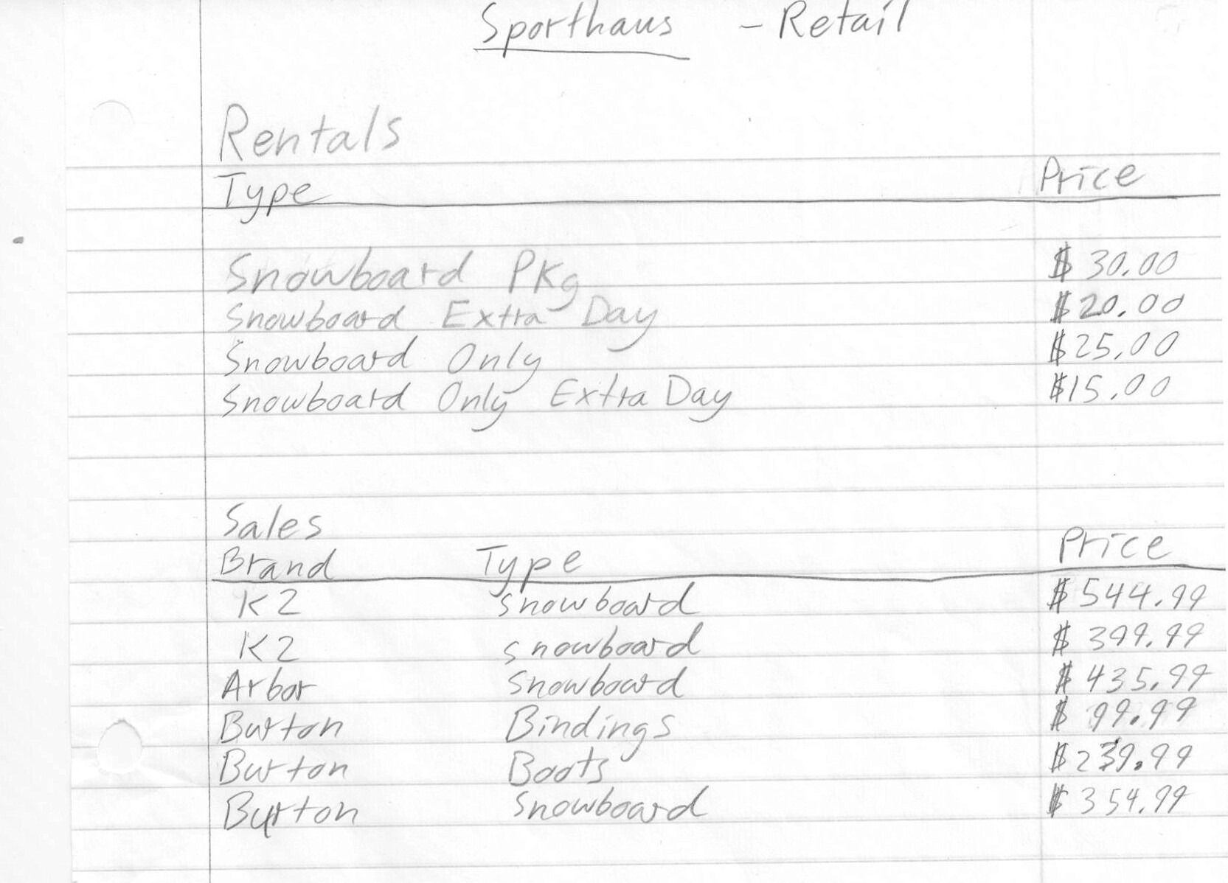
As the part numbers and quantities are important, businesses like Sporthaus cannot release this information.
It is difficult to keep track of all of the items and information in an organized manner. The incoming inventory and outgoing inventory must be continuously monitored. All of the item’s information also needs to be kept track of. All of this is important to keep the business running smoothly.
This is especially true when it comes to shrinkage. Shrinkage is the unaccounted for merchandise. It is important for a company to know exactly where its goods are going and where it might be losing money. Missing merchandise can be tracked by comparing the actual number of items in the store to the number of items that should be there.
When supply levels get low, the store needs to be notified. An improvement on this notification system is actually sending in an automatic order for the item that is low in stock. This can be achieved with computer monitoring rather than tedious, erroneous human-monitoring.
Once a customer buys an item, the item needs to be removed from the inventory. This seems simple but it must also be tracked for a period of time to check for shrink.
Renting adds another dimension to the problem as it does not leave stock unless it is actually broken. It leaves the store but is still considered the business’ property. This means it should still be in the system, but it can’t be counted as available to other customers.
Some companies have tried to solve these problems with programs like Retail STAR which is a point of sales program as well as an inventory system. I plan to concentrate my program on the problem of the inventory system. Simplicity and user-functionality are sometimes lost in large all-encompassing programs, but I think it is very important. The additional user capability will save time when customers need help.
Interview – Mark Harris – Inventory in general
Mark was a grocery store manager who had years of experience working up from the inventory counter to the manager. He helped to describe the basic needs of any inventory-record-keeping program and went into detail about possible scenarios involving the inventory. I learned about the background of inventory keeping and other things like shrink that must be accounted for using records.
-“Shrink is important to keep track of.”
- Shrink
  - Need to know what item is
    - All of item’s information for records
  - Check for shrink
    - Workers can check visually –visually identify
Or
    - **Track at inventory time – time consuming and expensive
      - Quarterly
      - **Semi-annually
      - Annually
  - Good to retain records
    - With shrink
      - Change total if there is shrink
      - Wipe slate clean at inventory
      - Write off (report/record)
    - Credits pending
      - When return flawed items to vendor
      - Product not here nor there
      - Waiting to get paid back
    - Valuable to look back at records to see what they should buy for next season
    - Historical sales
  - Positive shrink
    - Ex: not scanned items
    - Messes up inventory
    - Important to train employees
      - They need to scan each item individually
- Focus on items
- Auto replenishment
- Searching options
  - Dropdown box
    - Search by category (Ex: board), UPC#, Type (Ex: K2)

Interview Questions – Sporthaus manager Don
Don works at Sporthaus, which is a sports shop that sells many things like the snowboards and boots that my sample data will be composed of. He told me about their current system and its helpful functions. I learned that barcodes are essential to keep track of the goods. I also learned that the programs can get fairly complicated with extra functions.
- Does Sporthaus use barcodes or RFID tags?
Barcodes
- Does Sporthaus use an inventory program?
Yes
- If so, what kind?
A point of sale and inventory one called Retail Star
- Do you have a sample of an inventory list that I could use for my project?
Some examples to write down
- What would make an inventory program helpful?
- Reports
  - How much they had
  - How much they sold
  - How much they had left
- Scan barcodes to take out of inventory
- Keeps track of cost to buy items and the amount of money they get back
- Sends an invoice
  - When items come in
  - When bills need to be paid
- Sends order in when stock is low
A2 – Criteria for success
There are six main objectives that need to be met for the program to succeed.
- Users can input the information of a new item that was bought
- The new items get unique barcodes
- Users can see the entire list of inventory or records
- Users can input a barcode of a rentable item to mark it as “Rented Out” showing it as unavailable to other customers
- Users can search the entire inventory for items using the barcode, the type, or the brand
- Users can input a barcode to move an item that has left the store from the inventory into the records and label it as “Sold” or “Defective”
Below is a brainstormed more in-depth description of the objectives.
Inventory:
- Track inventory by barcode (UUID)
- Buy, Sell, and Rent items using barcode
- Keep track of shrinkage
- Search inventory
Items stored in a text file:
- Brand (Ex: K2)
- Type (Ex: Snowboard)
- Barcode (Ex: 00000000)
- Size (Ex: 152 or M or 7.5)
- Price (Ex: 35.00)
- Rental or Sale (Ex: R or S)
Buy:
- Add items
  - User inputted when return or missed item or. . .
    - Enters item information in special boxes
      - Brand (Ex: K2)
      - Type (Ex: Snowboard)
      - Barcode (Ex: 00000000)
      - Size (Ex: 152 or M or 7.5)
      - Price (Ex: 35.00)
      - Rental or Sale (Ex: R or S)
  - Computer auto replenish
    - Sends in order
    - Automatically enters item info
- Retail price will be double the whole sale cost
- Add item and barcode to inventory data structure
- Add item reference to the two search trees
Sell:
- Delete item from inventory
  - Sold – User deletes item
    - Enters barcode of item to be removed in special box
      - Ex: 00000000
  - Flawed items returned to vendor
    - User enters barcode in special box as item to be returned
      - Ex: 00000000
  - Computer deletes item from all three data structures
- Keep item info in records
  - Check semi-annually for shrink when taking inventory
Rent:
- Check out rented items
  - User
    - Enters barcode of item rented out in special box
  - Computer flags item as unavailable to others but item remains in inventory
- Check in rented items
  - User
    - Enters barcode of item returned in special box
  - Computer takes flag off of item and makes available to others
- Keep track of what is available
Search:
- Search by brand (Ex: K2)
  - User
    - Enters brand of item in special box
  - Computer searches data structure and outputs list of items with matching brand attribute
- Search by type (Ex: Snowboard)
  - User
    - Enters type of item in special box
  - Computer searches data structure and outputs list of items with matching type attribute
Records:
- Save all items sold and lost in records automatically
- Use records to track shrink semi-annually
Inventory
Buy
Sell/Lose
Search
Rent
Add Item to Inventory data structure
Add Ability to Search for New Items
Track all past inventory in records
Track shrink semi-annually at inventory time
By Brand (Ex: K2)
By Type (Ex: Snowboard)
Check Out Rented Items
Check In Rented Items

Delete Item f/ Inventory

By barcode (EX: 00000000)

Do same when return flawed items to vendor

By hand

Auto replenish inventory

Worker input – info page fill out

Computer sends in order and auto inputs info

Add to search data structures

Put item info in separate file

Inputs item# & computer removes from inventory & makes note in records

Delete from all three data structures

Worker counts by hand

Inputs any missing inventory into records & computer removes from data structures

Drop down option box

Flag
- Still in inventory
- Not available to other customers

Take flag off of item

Hierarchy Chart: Snowboard Shop Inventory
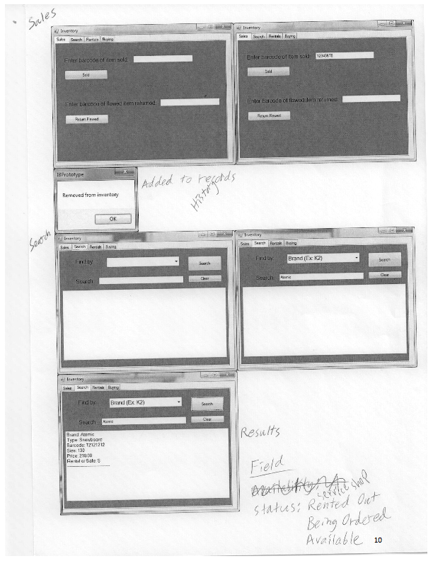

Program Structure

The main inventory will be in a HashMap with the barcodes as the keys and the items as the values. I first thought of putting the inventory in a BinaryTree because of the search efficiency, but I decided on a HashMap because the way barcodes are used seemed to match a HashMaps functionality more in that the barcode is the label used to keep track of the items. The HashMap is made of keys tied to values. The keys can be used to get the values from the data structure. The barcodes will be the keys and the actual Item objects will be the values.
Key: Barcode
-12345678
Value: Item Obj.
-Brand
-Type
-Barcode

-Size
-Price
-RentalSale

The two other search data structures will be BinaryTrees since they are only used to search. BinaryTrees are structured like a tree with one root node on top that has up to two children which each have up to two children and so on. The BinaryTrees will hold the actual Item objects in ArrayLists in each node. One BinaryTree will be sorted by the Brand attribute and the other one will be sorted by the Type attribute.
Brand
-Burton
Item Object
Item Object
Item Object

Brand
-K2
Brand
-Atomic

The physical inventory items will be represented by instances of the Item class. A RandomAccessFile object will be used to read and write inventory data to files. Originally I planned to have each Item be in its own file which would require the same amount of memory. This turned out to be inefficient, so I change the storage technique to one large RandomAccessFile containing all the records. A RandomAccessFile is used because during searching, selling, renting, and buying, only specific Item objects need to be accessed.
Items - Random AccessFile
Item Obj. 1
Item Obj. 2
Item Obj. 3
Item Obj. 4

The History records will be kept in sequential files because all the item data will need to be looked at during inventory time. And another sequential file will be used to save the number of items currently in inventory.

Record -Sequential File
Item Obj. 1
Item Obj. 2
Item Obj. 3
Item Obj. 4

Item number File
32

ULM – Classes

Inventory
InventoryHashMap: HashMap
BrandTree: BinaryTree
TypeTree: BinaryTree
ranFile: RandomAccessFile
Add(Item)
CheckShrink(seqFile)

Item
Brand: String
Type: String
Barcode: UUID
Size: String
Price: Double
RentalSale: String
Status: String
GenerateUUID()

RAFile
Create(ranFile,I)
Display(ranFile)
readFromFile(ranFile)
writeToFile(ranFile, Item)
setLength(String, int)

Buy
addToInventory(InventoryHashMap, Item)
autoBuy( InventoryHashMap, Item)
Search
searchByBarcode( InventoryHashMap, UUID)
searchByBrand(BrandTree, String)
searchByType(TypeTree, String)
Rent
SetFlag(Item)
RemoveFlag(Item)
Sell
removeFromInventory(InventoryHashMap, Item)
addToRecords(ranFile, Item)

Module Structures

Class: Inventory
Add(Item: item)
{
Pre: Item info is available
Post: Item is added to inventory HashMap and BrandTree and Type Tree binary trees
}

CheckShrink(File: seqFile)
{
Pre: seqFiles contain some information
Post: Return number of unaccounted for items and their info
}

Class: Item
GenerateUUID()
{
Pre: An item is being created
Post: Return the new unique 8-digit barcode number
}

Class: RAFile
Create(RandomAccessFile: ranFile, HashMap: InventoryHashMap)
{
Pre: InventoryHashMap conatins at least one item
Post: A RandomAccessFile should be made for each item
}

Display(RandomAccessFile: ranFile)
{
Pre: File referenced by ranFile must exist
Post: Contents of ranFile are printed out or if empty, “File is empty” message printed out
}

readFromFile(RandomAccessFile: ranFile, HashMap: InventoryHashMap, Tree: BrandTree, Tree: TypeTree)
{
Pre: File referenced by ranFile must exist
Post: Information is read in from ranFile and put in InventoryHashMap and SearchTrees
}

writeToFile(RandomAccessFile: ranFile, Item: item)
{
Pre: File referenced by ranFile must exist and item must exist
Post: item’s info is written to its own RandomAccessFile
}
setLength(String: st, int: x)
{
Pre: x is at least as long as the string
Post: the strings length equals x, if string is smaller, spaces are added
}

Class: Sell
removeFromInventory(HashMap: InventoryHashMap, Item: item, Tree: BrandTree, Tree: TypeTree)
{
Pre: item exists
Post: item is removed from InventoryHashMap and search trees. If item is not in data structures, print message
}

addToRecords(RandomAccessFile: ranFile, Item: item)
{
Pre: File referenced by ranFile must exist and item must exist
Post: item is written to its own file
}

Class: Buy
addToInventory(HashMap: InventoryHashMap, Item: item, Tree: BrandTree, Tree: TypeTree)
{
Pre: item exists
Post: item is added from InventoryHashMap and search trees. If item is already in data structures, print message
}

autoBuy(HashMap: InventoryHashMap, Item: item, Tree: BrandTree, Tree: TypeTree)
{
Pre: item exists
Post: item is added from InventoryHashMap and search trees. If item is already in data structures, print message
}

Class: Search
searchByBarcode(HashMap: InventoryHashMap, UUID: Barcode)
{
Pre: Barcode is 8-digit UUID
Post: Return the Item object that has the Barcode
}

searchByBrand(Tree: BrandTree, String: Brand)
{
Pre: Brand is a String
Post: Return a reference to the Item objects that has the Brand
}

searchByType(Tree: TypeTree, String: type)
{
Pre: Brand is a String
Post: Return a reference to the Item objects that has the Type
}

Class: Rent
SetFlag(Item: item)
{
Pre: item exists
Post: item’s status is set to “Rented Out”
}

RemoveFlag(Item: item)
{
Pre: item exists
Post: item’s status is set to “Available”
}
Error Handling
When using files, IOExceptions need to be continuously dealt with. At times when the program can move on without worrying about the exception, I throw the exception. Sometimes the work with the files is the main point of a method and therefore needs to be dealt with using a try-catch block that tells the user when an error occurs and what the action was that created it.
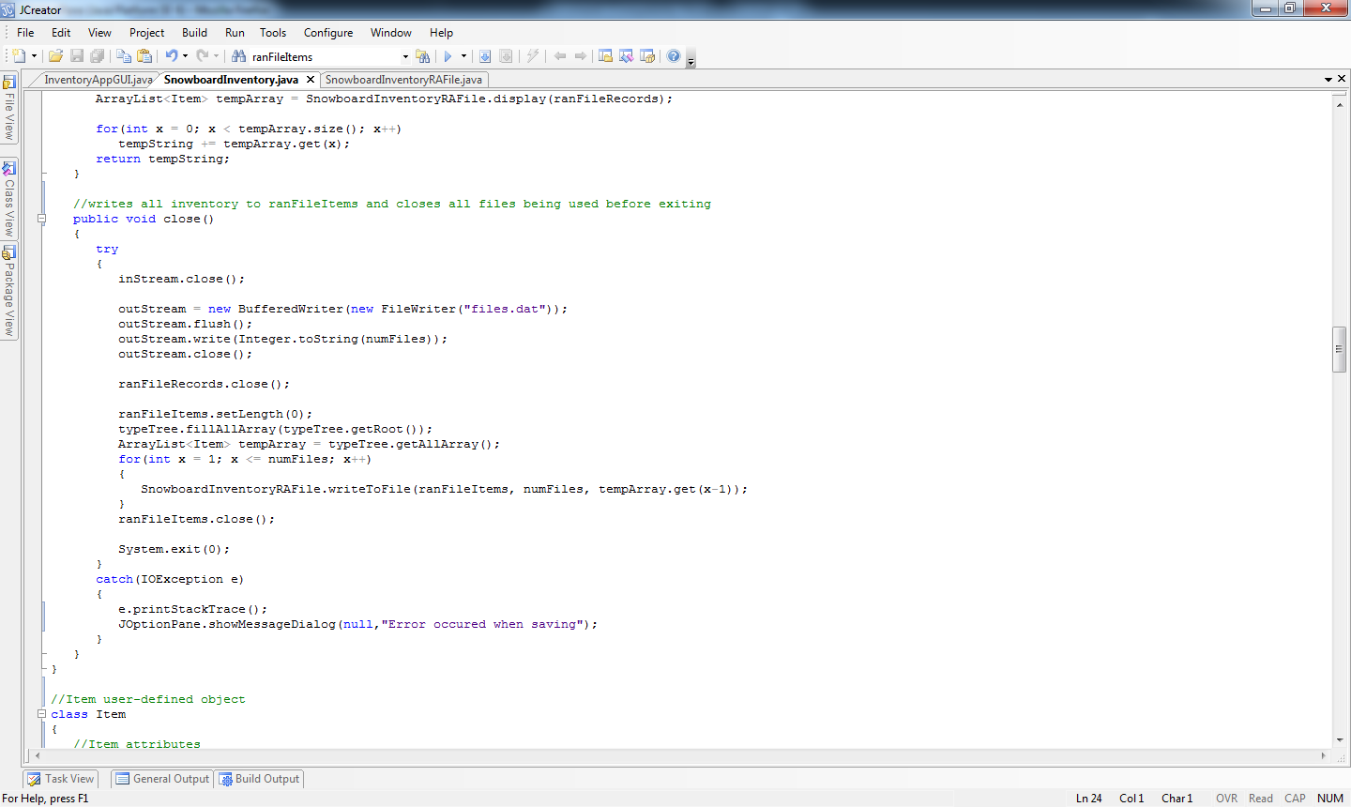

User-input is also checked for errors. Users of an inventory program will range from middle-school graduates to college graduates which means it needs to be simple enough to use and able to compensate for a users wrong input.
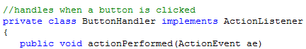

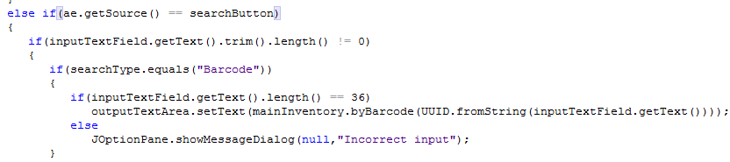
* * * * *
Success of the Program:

Objectives | Evidence
Users can input the information of a new item that was bought | 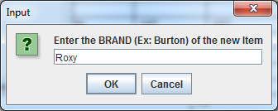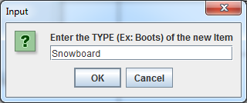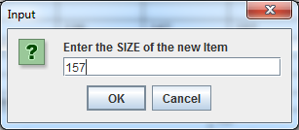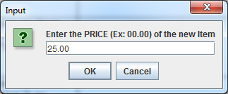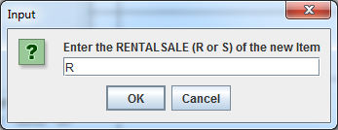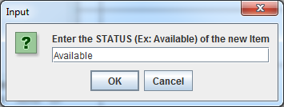
The new items get unique barcodes | 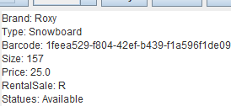
Users can see the entire list of inventory or records | 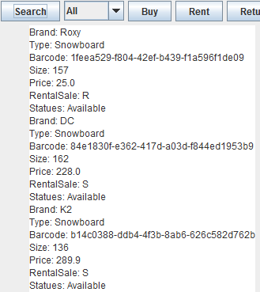
Users can input a barcode of a rentable item to mark it as “Rented Out” showing it as unavailable to other customers | 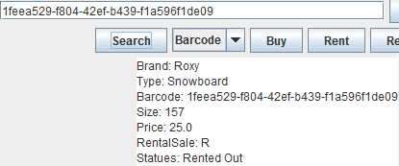
Users can search the entire inventory for items using the barcode, the type, or the brand | 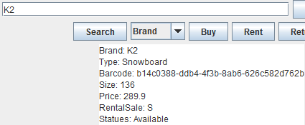  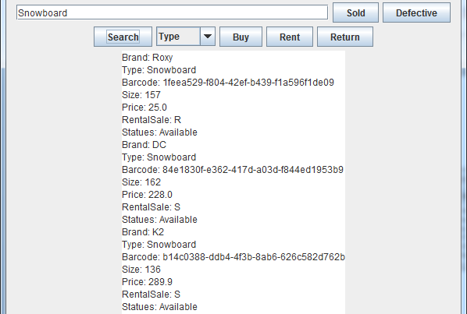
Users can input a barcode to move an item that has left the store from the inventory into the records and label it as “Sold” or “Defective” | 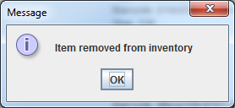  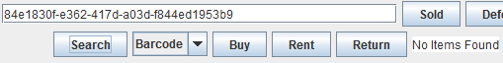  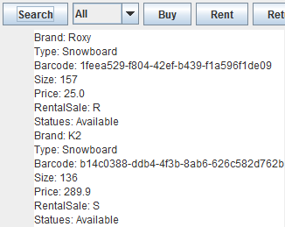

Sample Data
21
Brand: | *K2 | *Atomic | *Roxy | *K2 | *Atomic | *Roxy | *K2 | *DC | *Burton
Type: | Boots | Boots | Boots | Snowboard | Snowboard | Snowboard | Snowboard | Snowboard | Snowboard
Barcode:
Size: | 7 | 9.5 | 8 | 136 | 147 | 157 | 136 | 162 | 167
Price: | 174.95 | 68.95 | 89.95 | 25.00 | 25.00 | 25.00 | 289.90 | 228.00 | 290.95
RentSale: | S | S | S | R | R | R | S | S | S

Test For | Input | Expected | Output
Buying | Brand: K2  Type: Snowboard  Barcode:  Size: 136  Price: 25.00  RentSale: R  Status: Available | K2  Snowboard  **********************************  136  25.00  R  Available | K2  Snowboard  251b7406-531b-468e-a1c2-4b83b561d527136  136  25.00  R  Available  (In text file, the information has many spaces between and is on one line that is too long to copy here)
Selling | Barcode: 8a326400-c575-46d5-a51a-3a8b2612eb0a | Items.dat  -Item gone  Records.dat  -Item appended | 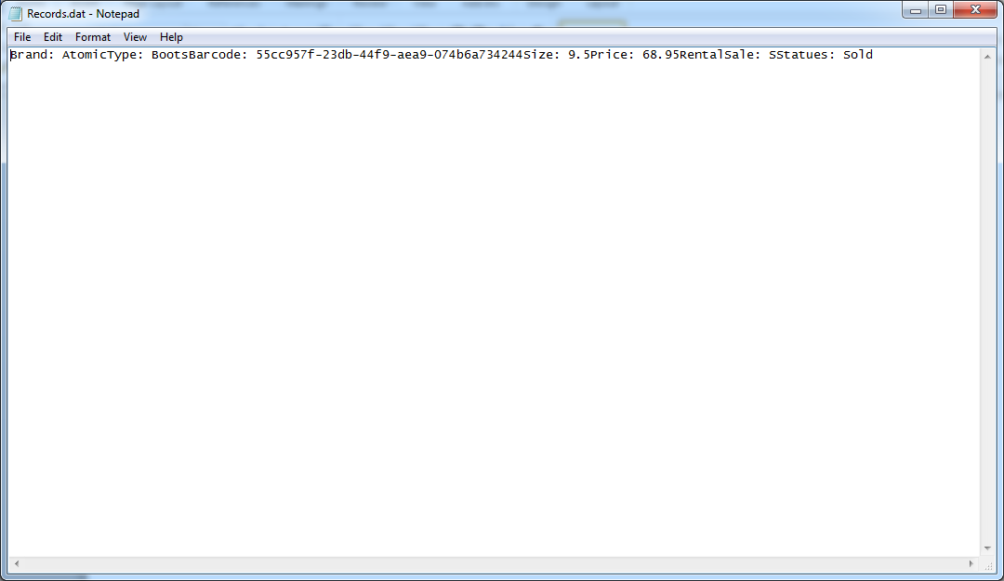
Renting | Barcode: 251b7406-531b-468e-a1c2-4b83b561d527136 | Item  Status: Rented Out | 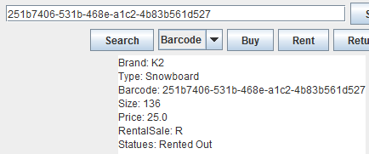
Searching | Type: Snowboard - with Snowboards | Brand: K2  Type: Snowboard  Barcode:  Size: 136  Price: 25.00  RentSale: R  Status: Available | 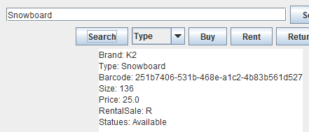  22
Searching | Brand: K2 – with K2’s | Brand: K2  Type: Snowboard  Barcode:  Size: 136  Price: 25.00  RentSale: R  Status: Available | 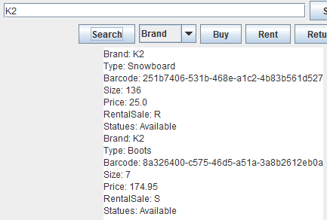
Searching | Type: Snowboard – without Snowboards | No Items Found | 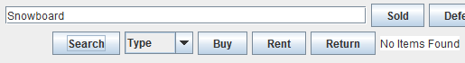
Displaying | All – with items in inventory | Brand: K2  Type: Snowboard  Barcode:  Size: 136  Price: 25.00  RentSale: R  Status: Available | 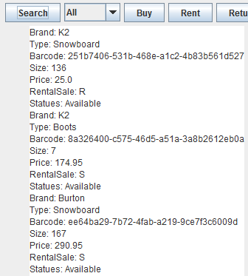  23
Displaying | All – without items in inventory | No Items in Inventory | 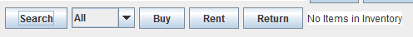

Evaluation of the Solution

The solution functions well as an inventory record application. Users can input information for a new item that is then given its own unique barcode. The barcode can be used to flag an item as rented out and to move an item to the records as “sold” or “defective”. The barcodes, brands, and types of the items can be used to search for and display the information of specific items. A list of the entire inventory or records to date can also be displayed.

The application is relatively easy to use as there are only a few controls to deal with and the back-coding is user-friendly, catching wrong input before it creates a problem. The user is sometimes prompted with input boxes such as when they add a new item. Other times the user is alerted when a function such as flagging an item as “Rented Out” is complete.

The code has an OOP format. It is long, but the functions such as buying and selling can be followed from one method to the next fairly easily as they use mostly different methods specific for that function. Sorting and searching is done often which are the complicated parts of the code.

Effectiveness
The solution completes each of the six main objectives specified in A2 Criteria for Success. From the user’s point of view, the application functions as expected and therefore has reached the objective in that sense. However, the presentation of displayed data is not fancy and would be hard to search through manually without more breaks between each item’s set of information.

The set-up behind the application works though at some points it seems convoluted. An example is that there are two search methods in the BinaryTree class. This is so one can be used by the user to search for items while the other is used by the program to find the item needing to be removed as it was sold or sent off as defective. This is not that terrible as in turn it makes the remove method much simpler.

An issue is the size of the files that the application uses to save item information in. The Items.dat holds the entire current inventory, but deleted items are only flagged in the file, not deleted. The Records.dat holds all of the information for every item sold, sent back as defective, or lost in some way from when the business first started using the program until the current time. This would make enormous files over time which would take up too much space on a simple business’ computer.

Efficiency
There may be some problems with efficiency as the program is used more. As the amount of inventory increases, the overhead caused by calling reading methods will increase making the program possibly lag as it reads in the numerous items’ information from text files.

The increase in inventory and recorded inventory over time will also decrease the memory efficiency of the program as information is never actually deleted as mentioned above. This would create problems in the future but could be fixed with some file management and semi-annual, or more frequent, file “cleaning”. Also, the Records.dat is not divided in anyway, creating one long list which is inefficient.

Possible Improvements
A main improvement would be to improve the set-up of the inventory and record files. It would help to divide the records files by month and to delete the old records semi-annually when the entire inventory is checked. An alternative that would be less time efficient especially with greater amounts of inventory would be to copy the entire current inventory to a new file each time an item is deleted. This, as mentioned above, could be more efficiently accomplished by “cleaning” the files semi-annually or more frequently. This could even be created as a setting the user can change to fit their needs.

The use of a HashMap and two BinaryTrees could be changed to make the data structures uniform. If they were all HashMaps, it would require less coding and the code would not be as complicated with the extra searching, adding, and removing methods gone.

The final GUI is not as nice or complicated as the prototype. The difficulty of designing the GUI while putting the back-code together was not initially apparent. Though it is not as nice, there are fewer controls for the user to get confused with. A GUI in between the extremes of the prototype and the final product would be better for the ease of use.

